Disease:Anthracnose

The term anthracnose refers to a group of fungal diseases that can affect a wide range of plant species, trees as well as shrubs, both ornamentals and edibles, and also garden crops. While the symptoms are similar, the fungi that cause the disease are different from host to host.

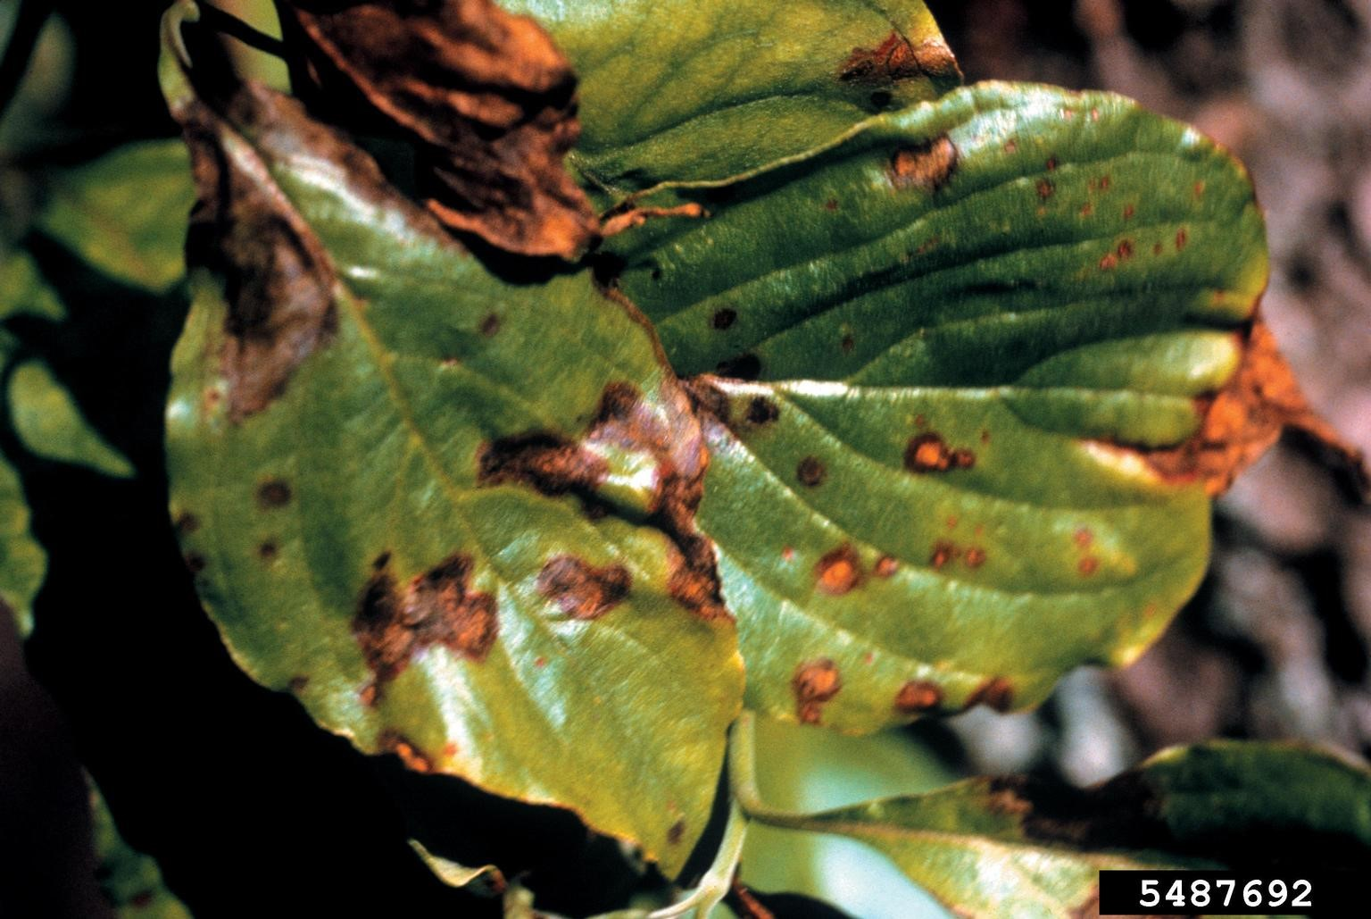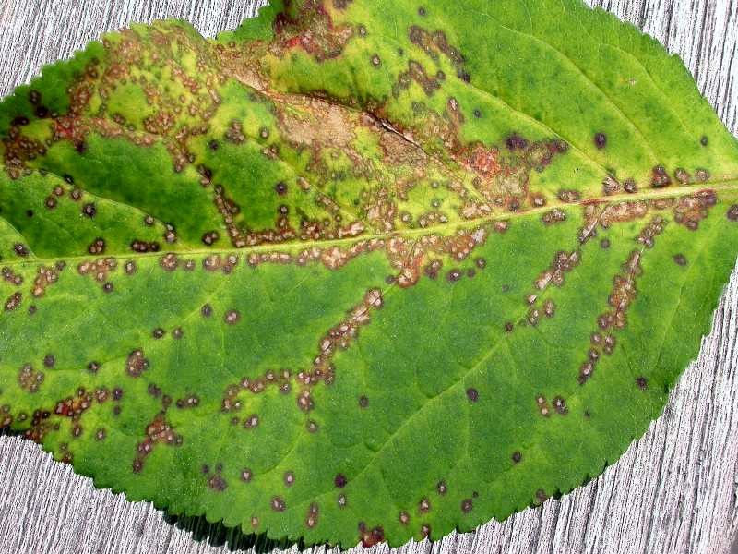

**How does it spread?**

This fungus can be seed-borne and carry over on crop residue in the soil. It is spread in water droplets and worse in warm, humid weather.

**Treatment**

# Pre-harvest treatment

Follow a recommended fungicide spray program for your crop from flowering to fruit set. Control fruit-damaging pests such as fruitspotting bug and fruit fly.

# Post-harvest treatment

Treat fruit after harvest with an appropriate chemical. Pre-cool fruit before transport if the time from harvest to delivery at the wholesale market exceeds two days. Store fruit until sale at the temperature recommended for that crop.

# Chemical registrations and permits

Check the Australian Pesticides and Veterinary Medicines Authority chemical database and permit database for chemicals registered or approved under permit to treat this disease on the target crop in your state or location.